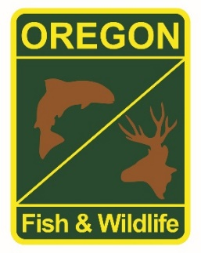

**State Fisheries Genetics Lab Tissue Sample Intake Form**

Please complete the top part of this form and send to: [kathleen.omalley@oregonstate.edu](mailto:kathleen.omalley@oregonstate.edu)

Make arrangements with us prior to dropping off the tissue samples and include a copy of this form with your samples.

**Project dropping off samples:**

Rogue Watershed District Office, Central Point

**Person dropping off samples:** Laura Street

**Phone: Email:**

541-826-8774 x 224 Laura.E.Street@state.or.us

**Description of samples (e.g. species, collection locations, collection dates, collection methods, number of samples, life stage; may attach spreadsheet):**

Adult summer steelhead collected from sorting pond at Cole Rivers Fish Hatchery on 6/26/2019. These are from fin clips taken during sorting. There are 4 wilds and 80 hatchery fish, they are in separate labeled vials.

**If applicable, known origin (e.g. natural or hatchery):**

4 wild and 80 hatchery

**Sample type (e.g. fin tissue, scale, muscle, etc):**

Fin Tissue

**Storage method (e.g. dry, 95% ethanol, RNA later, etc):**

95% ethanol